Leonardo da Vinci and the Scientific Revolution
Leonardo da Vinci and the Scientific Revolution |  | Difficulty
Leonardo da Vinci and the Scientific Revolution |  |  | 1

Name︰_______________ （ ） Class︰__________

Historical skill | Inducing and inferring, interpret paintings
Related Textbook Content | 2A pp. 15, 30-32

Study the sources below and answer the following questions.

Source A About studies conducted by Leonardo da Vinci during the Renaissance
Leonardo da Vinci’s greatest scientific achievement was in anatomy. At first, he studied the human body to draw people realistically. Later, he became curious and spent more time studying the structure of human body. He used a well-proportioned male as a model and created The Vitruvian Man, showing a perfect proportion of human body. In the drawing, the height of the body and the outstretched arms are each divided into eight equal parts, forming sixty‑four small squares. This idea of perfect proportion is known in mathematics as the Golden Ratio.

Source B Portriat of Andreas Vesalius, his book On the Fabric of the Human Body is a famous work in Subject X.
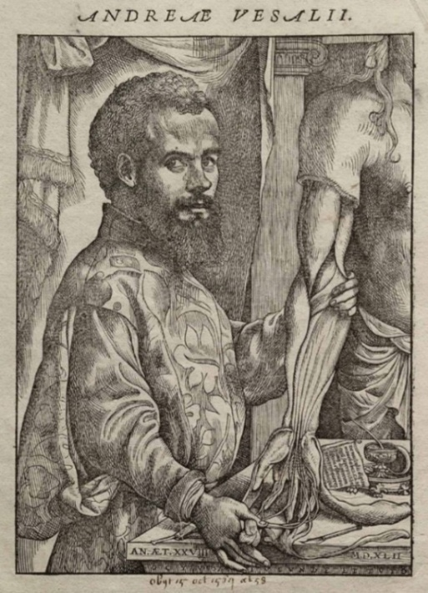
1. As reflected in Source A, which kind of knowledge did Leonardo da Vinci has? (add ) Understand sources
Arts
Mathematics
Science
Architecture

2. Which subject was Subject X as mentioned in Source B? Cite one clue from the source to support your answer. Observe sources
Tips: Pay attention to the actions of the person in the painting.

Mathematics
Anatomy
Biology
Architecture
Clue: __________________________________________________________________

3. In which ways did Leonardo da Vinci prompt Vesalius’ studies in Subject X? Explain your answer with reference to sources above and based on your own knowledge. Analyse event relationship
Source A pointed out that Leonardo da Vinci studied the _______________ of human body and drew a painting with _______________. These achievements prompted scholars to conduct more scientific studies in the later years. Based on my own knowledge, Vesalius was a scholar during the [ Industrial Revolution ／ Scienice Revolution ], which occurred after the Renaissance. With reference to Source B, the famous work by Vesalius _______________ [ has ／ did not have ] relations with the scientific research conducted by Leonardo da Vinci. This shows that ______________ inspired the studies made by Vesalius.

Answers

1.
Arts
Mathematics
Science
Architecture

2.
Mathematics
Anatomy
Biology
Architecture
Clue: The famous work by Vesalius On the Fabric of the Human Body is mostly related to Anatomy. / The portrait depicted Vesalius conducting dissection and research to a human body. (choose any one)

3. Source A pointed out that Leonardo da Vinci studied the ______structure_____ of human body and drew a painting with ______perfect proportions________. These achievements prompted scholars to conduct more scientific studies in the later years. Based on my own knowledge, Vesalius was a scholar during the [ Industrial Revolution ／ Scienice Revolution ], which occurred after the Renaissance. With reference to Source B, the famous work by Vesalius _____On the Fabric of the Human Body___ [ has ／ did not have ] relations with the scientific research conducted by Leonardo da Vinci. This shows that ____Leonardo da Vinci_____ inspired the studies made by Vesalius.

